You are required to deploy a Flask backend and an Express frontend application using AWS and Terraform. Follow the steps below to deploy the applications in different configurations.

Part 1: Deploy Both Flask and Express on a Single EC2 Instance
- Objective: Deploy both the Flask backend and the Express frontend on a single EC2 instance using Terraform.
  - Provision the EC2 instance with Terraform.
  - Configure the instance with:
    - A user data script or a configuration management tool (e.g., Ansible or Cloud-Init) to install dependencies (Python, Node.js).
    - Scripts to start the Flask backend and the Express frontend.
  - Ensure both applications are running on different ports (e.g., Flask on port 5000 and Express on port 3000).
- Expected Deliverables:
  - Terraform configuration files (main.tf, variables.tf, etc.).
  - A working EC2 instance with Flask and Express running and accessible via the instance's public IP.

Part 2: Deploy Flask and Express on Separate EC2 Instances
- Objective: Deploy the Flask backend and the Express frontend on two separate EC2 instances using Terraform.
  - Provision two EC2 instances using Terraform:
    - One for the Flask backend.
    - One for the Express frontend.
  - Configure security groups to:
    - Allow communication between the two instances.
    - Expose both applications to the internet on their respective ports.
- Configuration:
  - Use Terraform to define networking resources, such as VPC, subnets, and security groups.
  - Use user data scripts to automate the installation and startup of both applications.
- Expected Deliverables:
  - Terraform configuration files.
  - Two working EC2 instances: one running Flask and one running Express.
  - Security groups configured to allow proper communication and public access.

Part 3: Deploy Flask and Express Using Docker and AWS Services
- Objective: Deploy Flask and Express as Docker containers using AWS ECR, ECS, and VPC with Terraform.
- Steps:
  - ECR:
    - Use Terraform to create two Elastic Container Registry (ECR) repositories: one for the Flask backend and one for the Express frontend.
    - Build Docker images for both applications and push them to their respective ECR repositories.
  - VPC:
    - Use Terraform to create a VPC with subnets, route tables, and security groups.
  - ECS:
    - Use Terraform to set up an ECS cluster.
    - Create two ECS services:
      - One for the Flask backend.
      - One for the Express frontend.
    - Use ECS Fargate or EC2 launch type to deploy the containers.
  - Load Balancer:
    - Use Terraform to provision an Application Load Balancer (ALB).
    - Configure ALB listeners to route requests to the appropriate ECS service.
- Expected Deliverables:
  - Terraform configuration files for ECR, ECS, VPC, and ALB setup.
  - Docker images pushed to ECR.
  - ECS services running and accessible via the ALB.

General Requirements
- Ensure that all Terraform configurations follow best practices, including the use of variables.tf and outputs.tf.
- Use Terraform State (e.g., S3 backend) for state management.
- Use terraform plan and terraform apply to validate and deploy infrastructure.
- Document the deployment process in a README.md file.

Screenshots:
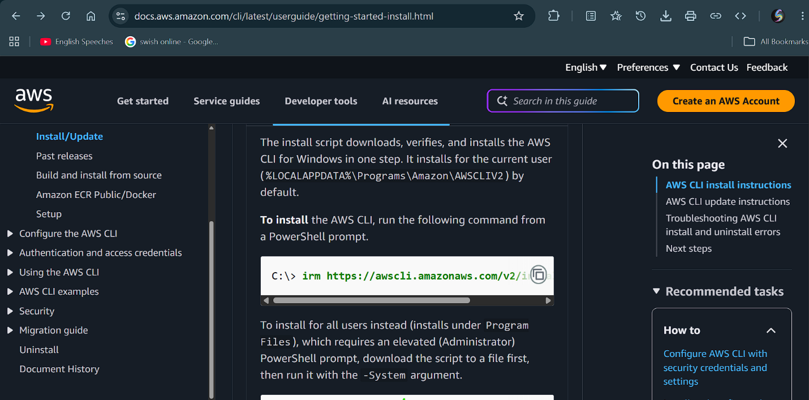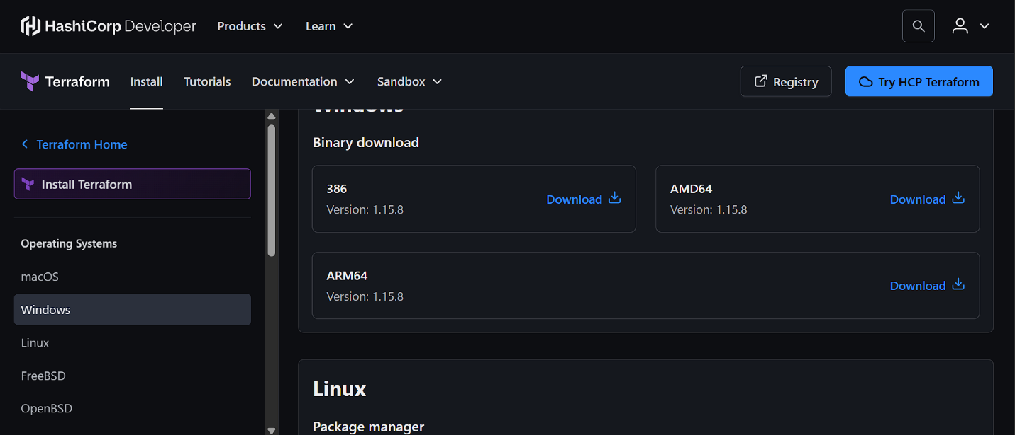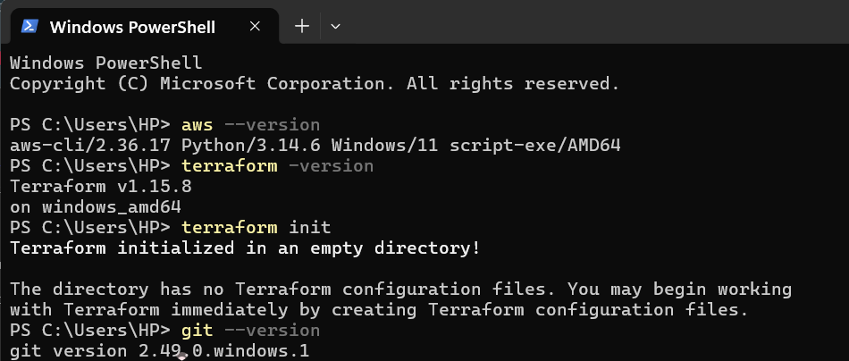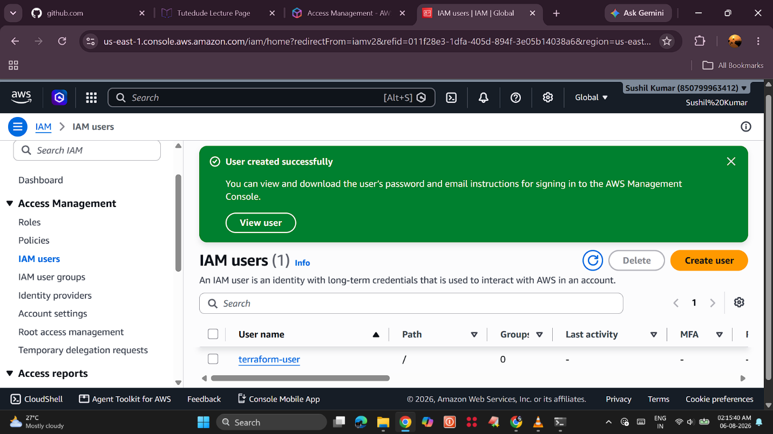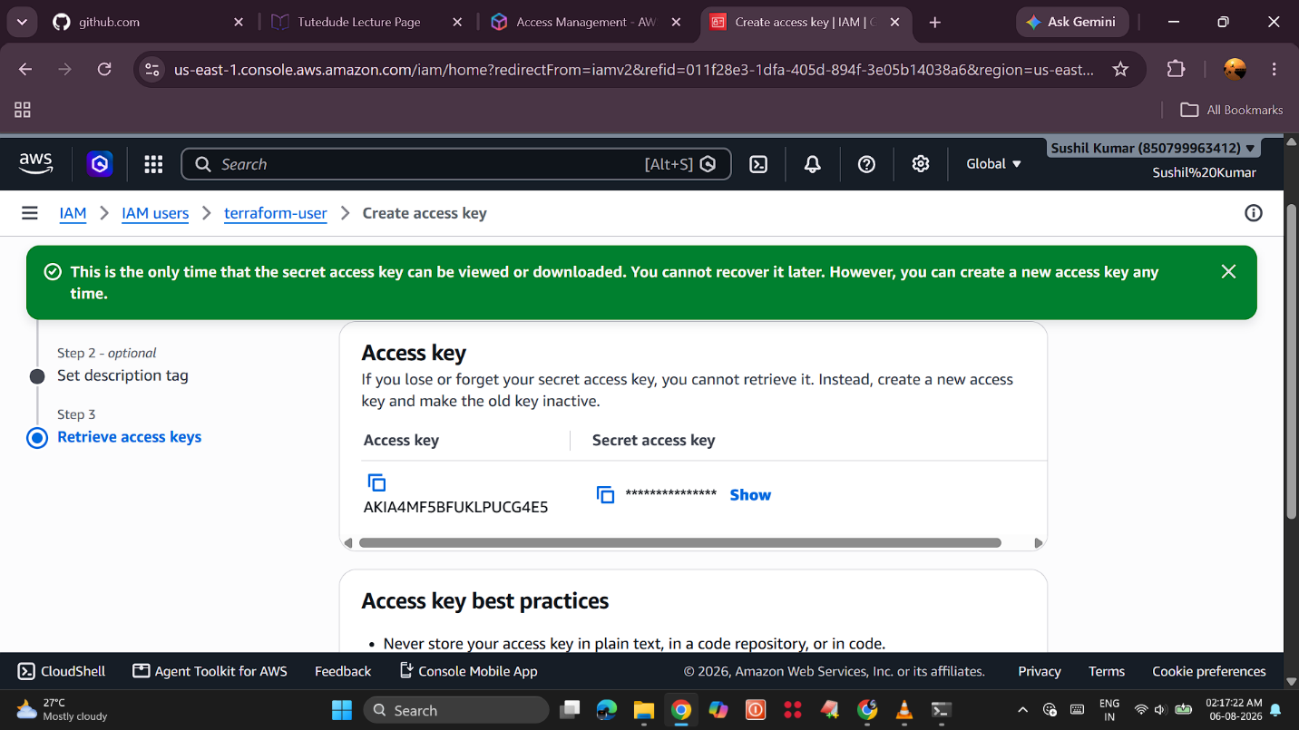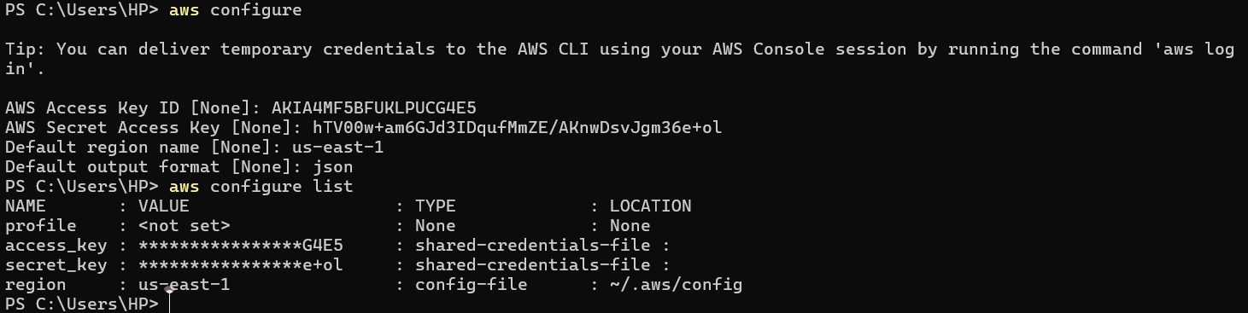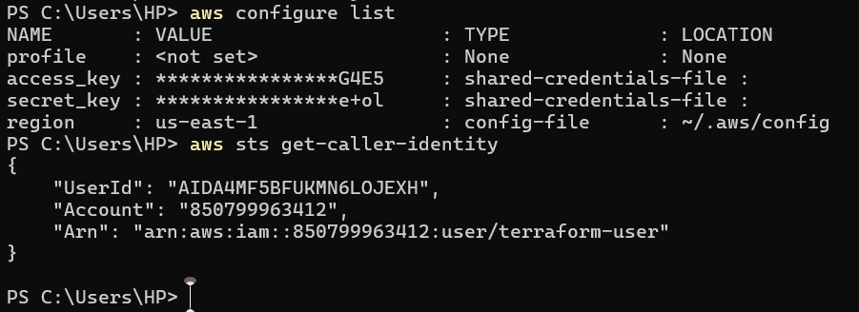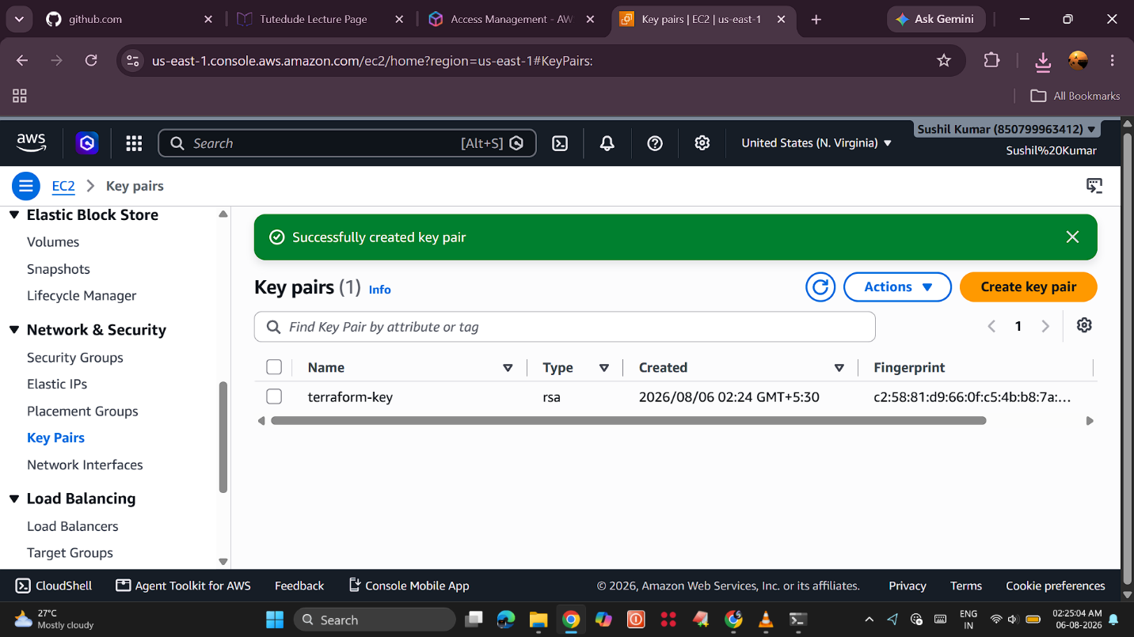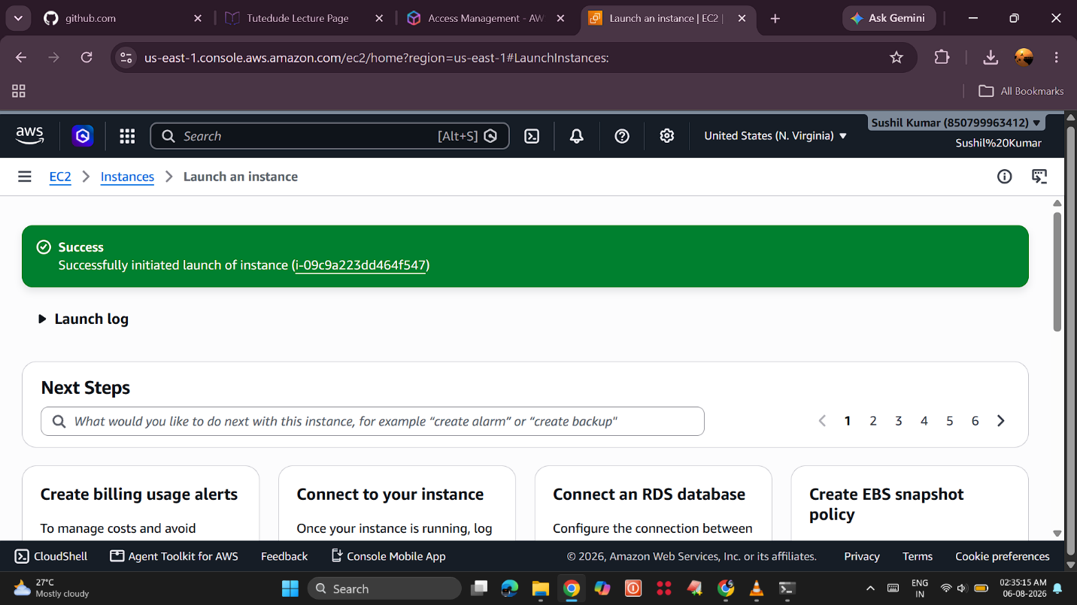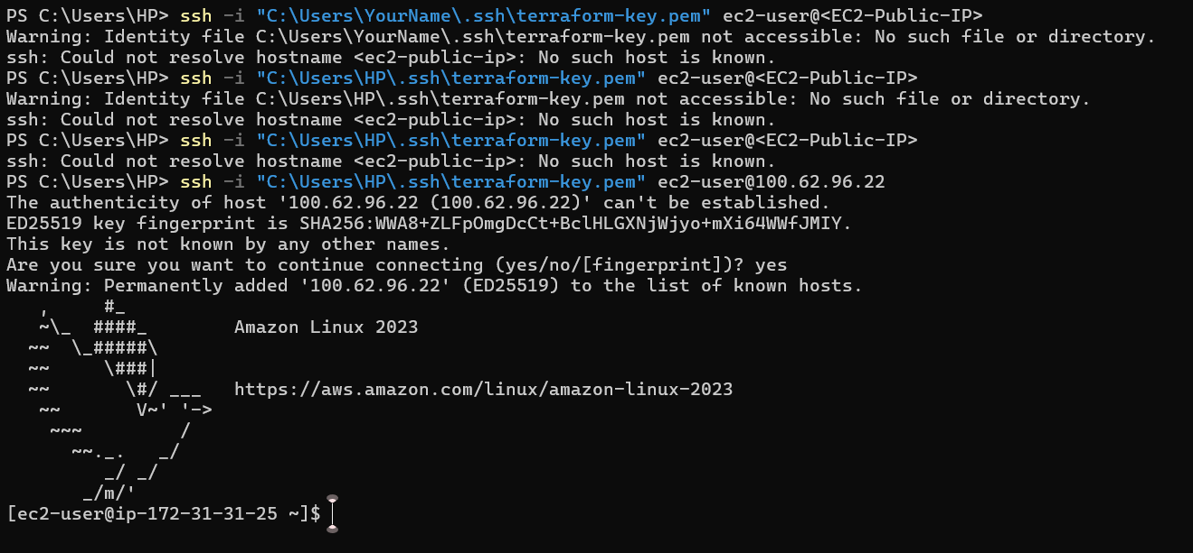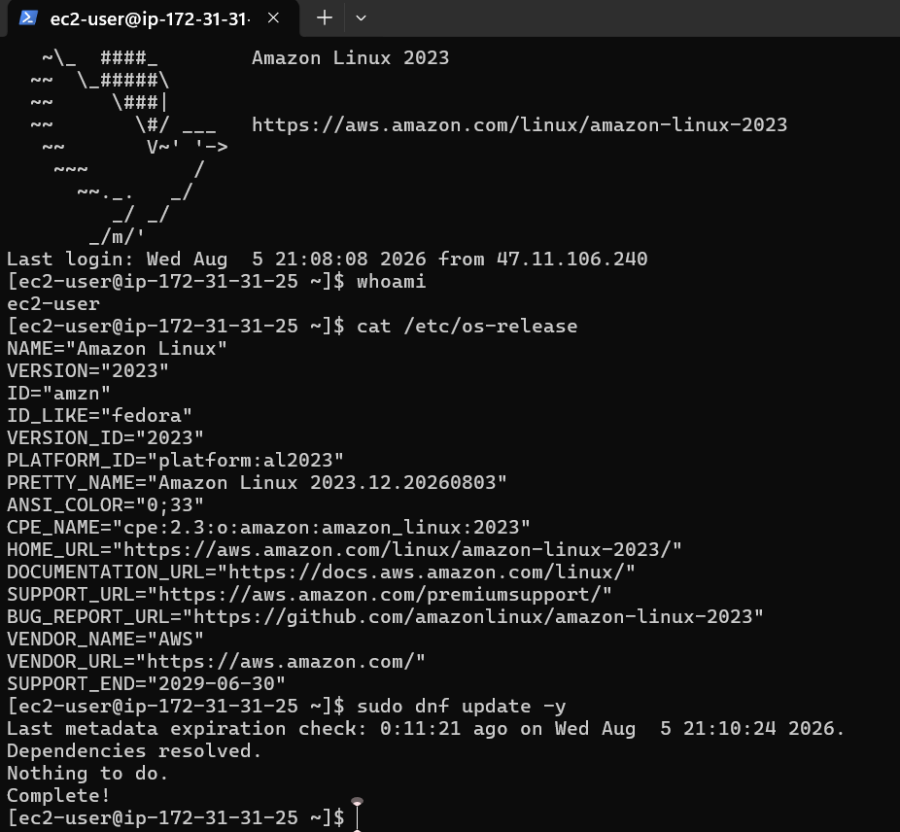

Commands:

# ===========================
# UPDATE THE SERVER
# ===========================

sudo dnf update -y

# ===========================
# INSTALL GIT
# ===========================

sudo dnf install git -y

git --version

# ===========================
# INSTALL PYTHON
# ===========================

sudo dnf install python3 python3-pip -y

python3 --version

pip3 --version

# ===========================
# INSTALL FLASK
# ===========================

pip3 install flask

python3 -c "import flask; print(flask.__version__)"

# ===========================
# INSTALL NODE.JS & NPM
# ===========================

sudo dnf install nodejs npm -y

node -v

npm -v

# ===========================
# CREATE EXPRESS APP
# ===========================

mkdir express-app

cd express-app

npm init -y

npm install express

cat > app.js << 'EOF'
const express = require("express");

const app = express();

app.get("/", (req, res) => {
res.send("Hello from Express Backend");
});

app.listen(3000, "0.0.0.0", () => {
console.log("Express Server Running");
});
EOF

node app.js

# (Press Ctrl+C after testing)

# ===========================
# CREATE FLASK APP
# ===========================

cd ~

mkdir flask-app

cd flask-app

cat > app.py << 'EOF'
from flask import Flask

app = Flask(__name__)

@app.route("/")
def home():
return "Hello from Flask Backend"

app.run(host="0.0.0.0", port=5000)
EOF

python3 app.py

# (Press Ctrl+C after testing)

# ===========================
# FIND EC2 PUBLIC IP
# ===========================

curl ifconfig.me

GitHub repo link:

